Topic 6.8: Combination Sum II
Question
Given a collection of candidate numbers (candidates) and a target number (target), find all unique combinations in candidates where the candidate numbers sum to target.
- Each number in candidates may only be used once in the combination.
- The solution set must not contain duplicate combinations.
Aim
To generate all unique combinations of candidate numbers that sum to the target, where each candidate is used at most once, and duplicate solutions are avoided.
Algorithm
- Sort the array candidates to handle duplicates easily.
- Use backtracking to explore possible combinations:
  - Keep track of the current path and remaining target.
  - If the target reaches zero, store the combination.
  - If the target goes negative, backtrack.
- Skip over duplicate elements to ensure unique combinations.
- Ensure that each number is used at most once by moving the recursive index forward.
Output
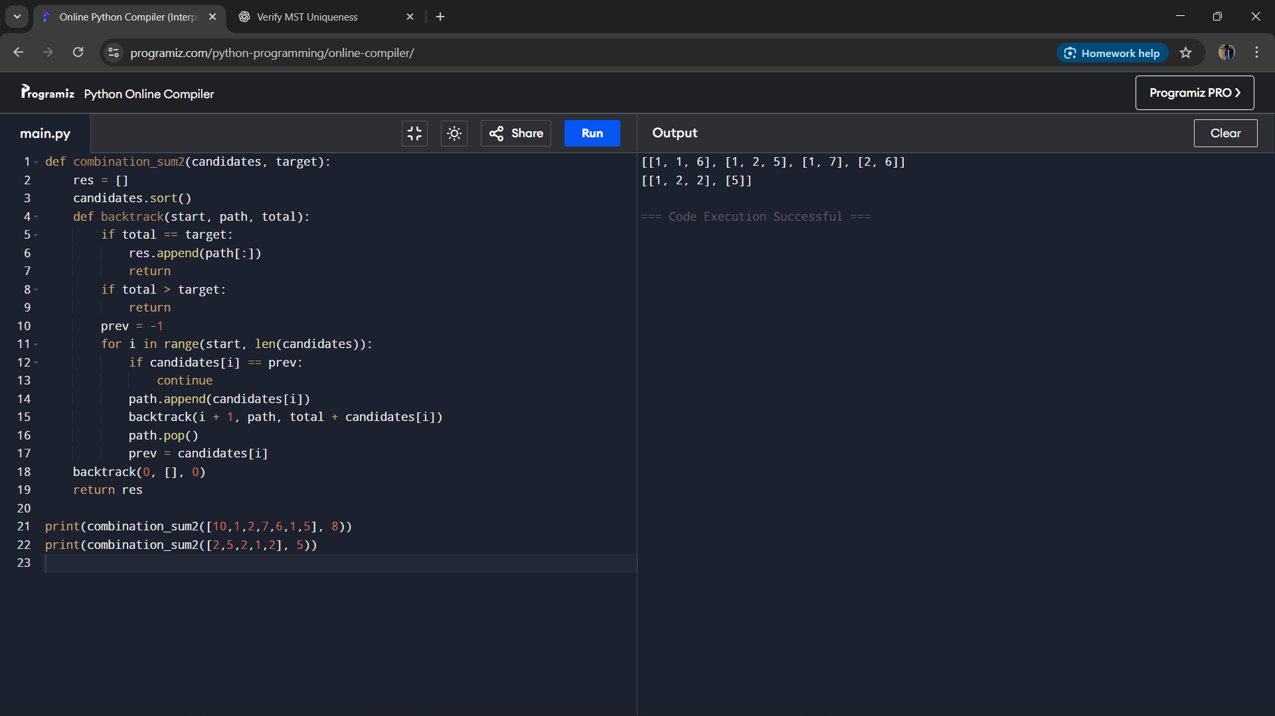
Result
The program successfully generates all unique combinations where each candidate number can be used only once, and duplicate solutions are eliminated.
Performance Analysis
- Time Complexity: O(2^n), where n is the number of candidates, due to exploring subsets.
- Space Complexity: O(n) for recursion stack and temporary combinations.

